INTRODUCTION

Project Overview

The Strategic Product Placement Analysis is an advanced analytical framework designed to quantify how the physical location of a product within a retail environment directly influences consumer purchasing behavior. By leveraging Tableau Visualization, this project transforms raw transactional data into a strategic tool that "unveils" hidden sales patterns and provides actionable insights for shelf-space optimization.

purpose

Quantify Revenue Lift: Measure the exact sales increase when moving products to "Prime" zones like eye-level or end-caps.

Map Customer Behavior: Align the customer's in-store journey with transaction data to see how placement drives choice.

Integrate Data Silos: Merge planogram files from cloud storage with live POS database transactions for a unified view.

Enable Field Action: Deliver mobile-responsive Tableau dashboards so managers can make "Keep or Move" decisions on the spot.

- Ideation Phase
Define the Problem Statements

Customer Problem Statement Template:
- The Customer

Who is the customer?

The primary customers are Retail Store Managers, Category Analysts, and Merchandising Directors who manage physical store layouts.
What is the customer's goal?
To maximize revenue per square foot by ensuring high-margin products are placed in the most visible and accessible locations for shoppers.

The Problem

What is the problem?

There is a significant "Visibility Gap." Stakeholders know what is selling, but they don't have a visual way to see where it is selling best within the store.
When does the problem occur?

This occurs during Shelf Planning (Plannogramming) and Monthly Sales Reviews when managers try to figure out why certain high-quality products are underperforming.

Where does the problem occur?
On the retail floor—specifically in "Dead Zones" (corners or bottom shelves) that receive high foot traffic but low sales conversion.

The Impact

How does it affect the customer?

Without spatial data, managers make "gut-feeling" decisions. This leads to Revenue Leakage, where expensive floor space is wasted on low-margin items while premium products remain hidden.
What is the negative outcome?
Lower "Average Basket Value" because customers aren't being guided toward complementary or impulse-buy products through strategic placement.

The Ideal State

What is the desired outcome?

An Interactive Tableau Dashboard that overlays transaction data onto a 2D store map.

How will this help?

Managers will be able to "see" the sales impact of moving a product from a bottom shelf to eye level, allowing them to transform low-performing aisles into high-profit zones.

Problem Statement Summary

"Retail Managers are currently struggling to quantify the financial impact of product positioning. Because they lack visual analytics, they are unable to identify 'Dead Zones' on the floor. Our project solves this by using Tableau Visualization to map sales data to physical locations, enabling data-driven placement that increases overall store profitability.”

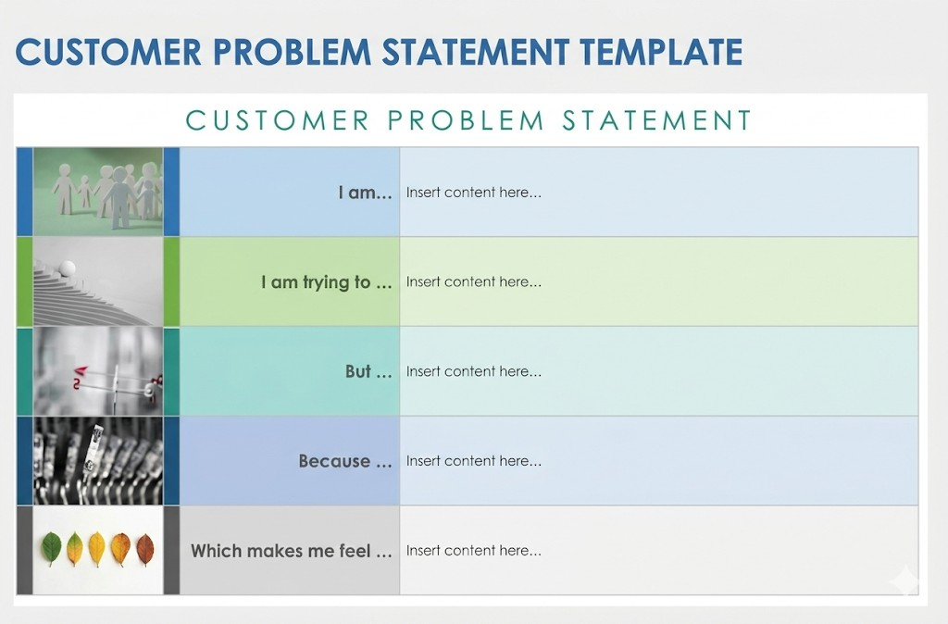

Component Project-Specific Matter

I am a: Retail Store Manager or Category Analyst responsible for maximizing store revenue and managing shelf inventory.

I’m trying to optimise product placement on shelves and within store zones to increase sales of high-margin items.

But I lack visual data to see which specific locations (eye-level vs. bottom shelf) or store zones are "dead zones" vs. "hot spots".

Because current sales reports only show what sold, not where it sold, making it difficult to quantify the spatial impact on consumer behavior.

Which makes me feel Frustrated and uncertain about whether the current store layout is actually maximizing potential profit.

2.Ideation Phase Empathize & Discover

Empathy Map Canvas:
Empathy Map: Retail Manager

- WHO are we empathizing with?
  - User: Retail Store Manager / Category Analyst.
  - Goal: To maximize sales by placing the right products in the right spots.
- What do they SEE?

  - Complicated spreadsheets with rows of numbers.
  - "Dead zones" in the store where customers don't stop.

  - Competitors using advanced heat-mapping technology.
- What do they SAY?
  - "I think the bottom shelf is killing our sales for this brand."
  - "We need a visual way to see our floor performance."
  - "Why is this high-margin item not moving?"
- What do they DO?
  - Manually move products based on "gut feeling."
  - Spend hours trying to cross-reference sales with floor maps.
  - Ask staff which aisles seem the busiest.
- What do they HEAR?
  - From Boss: "Revenue per square foot must increase by 10%."
  - From Staff: "Customers are complaining they can’t find the promotions."
  - From Tech: "Tableau can solve this if we have the right data."
- What do they FEEL? (Pains & Gains)
  - PAIN: Frustrated by "invisible" sales losses they can't prove.
  - GAIN: Excited to finally see a Heat Map that shows exactly where the money is.

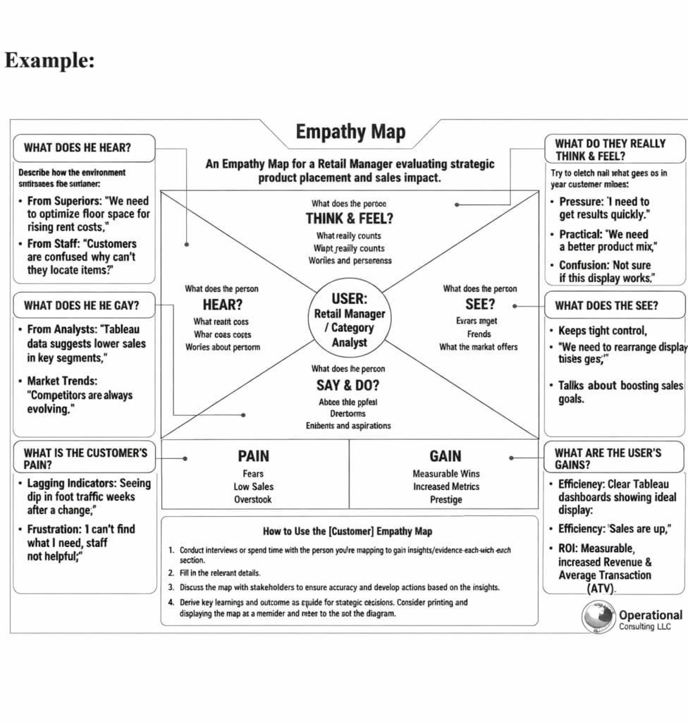

Ideation Phase
Brainstorm & Idea Prioritization Template

PROJECT COMPONENT: BRAINSTORM & IDEA PRIORITIZATION

Project Name: Strategic Product Placement Analysis: Unveiling Sales Impact with Tableau Visualization

Objective: To identify and prioritize data-driven strategies that optimize product positioning to maximize retail revenue.

Conceptual Brainstorming

Before building the dashboard, we categorized potential factors that influence consumer behavior into four key areas:

  - Spatial Mapping: How the physical layout (Aisle vs. Entrance) dictates foot traffic.
  - Vertical Hierarchy: The impact of shelf height (Eye-level vs. Reach-level) on brand conversion.
  - Product Affinity: The correlation between neighboring products (Cross-merchandising).
  - Temporal Dynamics: How placement effectiveness changes based on peak shopping hours.

Idea Prioritization Framework
This framework serves as the roadmap for our analysis, categorizing ideas by their strategic value and implementation priority.

Category: Zone Profitability

  - Description: Mapping revenue to a physical 2D store layout.
  - Strategic Value: High. It identifies "Hot" spots (high sales) and "Cold" spots (dead zones).
  - Priority: Critical (P1).

Category: Shelf-Level Lift

  - Description: Calculating the percentage growth in sales when a product is moved to eye-level.
  - Strategic Value: High. It optimizes the shelf stocking strategy for high-margin goods.
  - Priority: Critical (P1).

Category: Market Basket Analysis

  - Description: Analyzing if placement near complementary items increases the total order size.
  - Strategic Value: Medium. It helps increase the Average Order Value (AOV).
  - Priority: High (P2).

Category: Time-of-Day Impact

  - Description: Determining if placement matters more during morning rushes versus evening rushes.
  - Strategic Value: Low. It is harder to execute frequent physical changes to a store layout.
  - Priority: Low (P3).

Implementation Logic
To execute these prioritized ideas, the project will follow this logical flow:

  - For Zone Profitability: We will use Tableau Spatial Files or custom background images of the store floor plan to create a Heat Map. This allows stakeholders to visualize the "Value of Space" instantly.
  - For Shelf-Level Lift: We will use Grouped Bar Charts to compare sales across four specific levels: Top Shelf, Eye-Level, Touch-Level, and Bottom Shelf.
  - For Market Basket Analysis: We will utilize Highlight Tables to show the correlation between the placement of "Product A" and the sales lift of "Product B."

Strategic Justification

We have labeled Zone Profitability and Shelf-Level Lift as Critical. Because retail floor space is expensive, understanding the "Revenue per Square Foot" based on exact location provides the fastest Return on Investment (ROI) for store managers and

Step-1:
Team Gathering, Collaboration and Select the Problem Statement
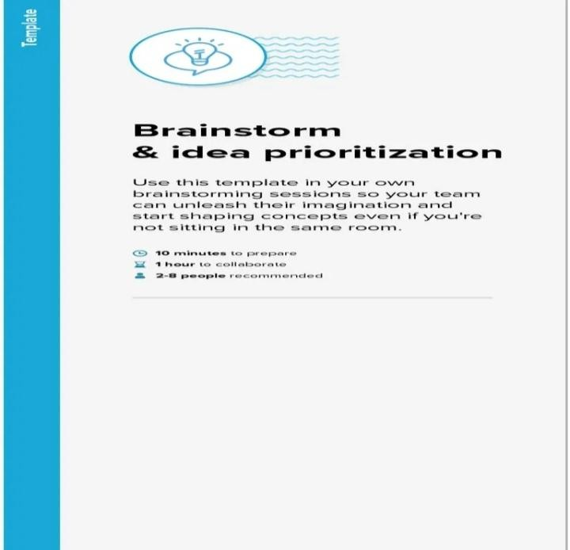

Step-2:
Brainstorm, Idea Listing and Grouping

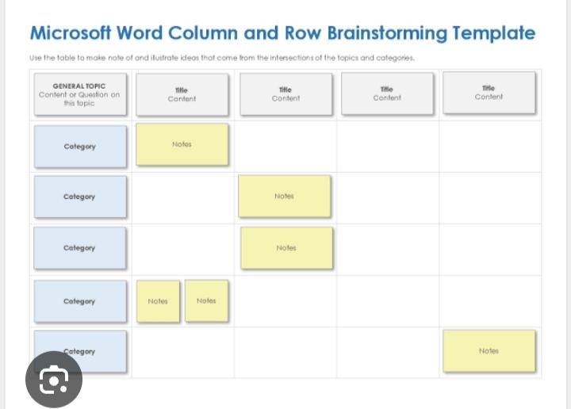

Step-3:
Idea Prioritization
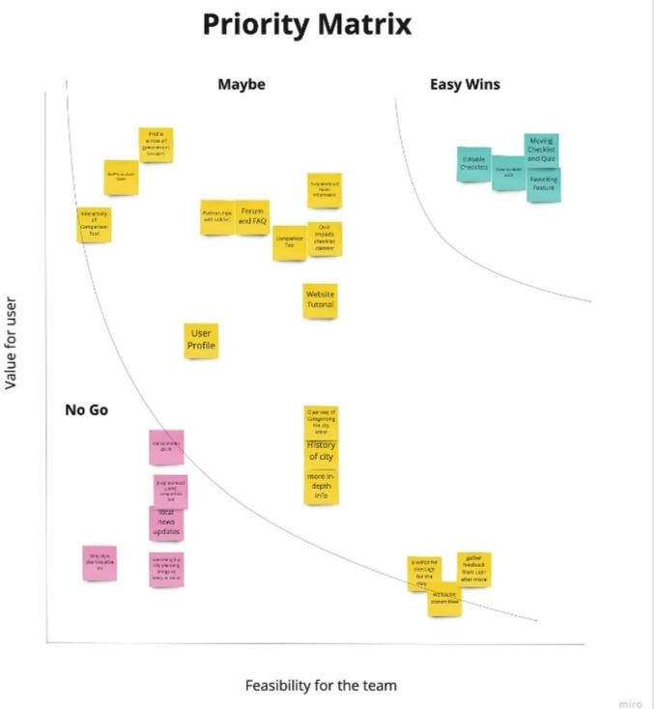

Customer Journey Map

Strategic product placement analysis: unveiling sales impact with tableau visualization

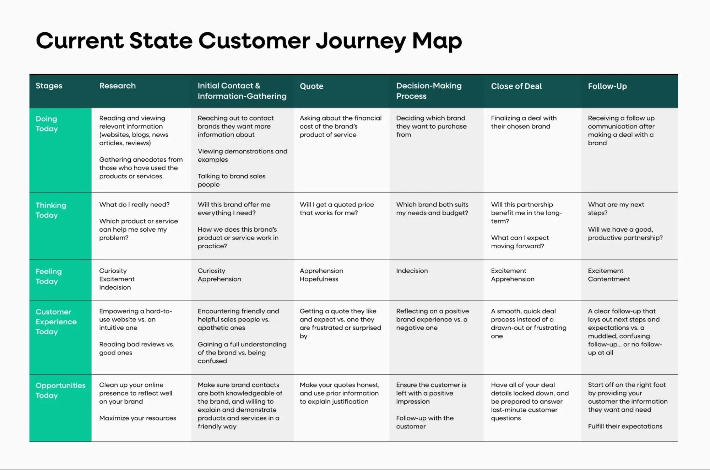

4.Project Design Phase-II
Solution Requirements (Functional & Non-functional)

Functional Requirements:
Following are the functional requirements of the proposed solution.

FR No | Functional Requirement (Epic) | Sub Requirement (Story / Sub-Task)
FR-1 | Data Collection and Extraction of Data | - Collect the dataset  - Understanding the Data  - Connecting the dataset with Tableau
FR-2 | Data Preparation | - Prepare the Data for Visualization
FR-3 | Data Visualization | - No of Unique Visualizations
FR-4 | Dashboard | - Responsive and Design of Dashboard
FR-5 | Story | - No of Scenes of Story
FR-6 | Performance Testing | - Utilization of Filters  - No of Calculation Fields

 |  | - No of Visualizations/ Graphs
FR-7 | Web integration | - Dashboard and Story embed with UI With Flask
FR-8 | Project Demonstration & Documentation | - Record an explanation Video for the project end to end solution  - Project Documentation-Step by step project development procedure

Non-functional Requirements:
Following are the non-functional requirements of the proposed solution.

FR No | Non-Functional Requirement | Description
NFR-1 | Usability | The dashboard must feature an intuitive UX, allowing category managers to filter by region, SKU, and shelf position with zero training. It should follow visual best practices (e.g., color-blind friendly palettes).
NFR-2 | Security | Data access must be governed by Row-Level Security (RLS),  ensuring regional managers only see data for their specific stores. Connection to the data source must be encrypted via SSL/TLS.
NFR-3 | Reliability | The system must

maintain 99.9% data accuracy between the source ERP/POS system and the Tableau visualization.
Automated data quality checks should flag anomalies in sales impact metrics.
NFR-4 | Performance | Dashboards must load within 3-5 seconds. Data extracts or Live queries must be optimized (using indexing or partitioning) to ensure smooth interaction when toggling between "Before" and "After" placement views.
NFR-5 | Availability | The visualization must be accessible 24/7 via Tableau Server/Cloud, with scheduled maintenance occurring only during off-peak hours to ensure stakeholders can run reports whenever needed.
NFR-6 | Scalability | The solution must support a 50% increase in data volume (new store locations or products) and an increase in concurrent

users without a degradation in rendering speed.

- Project Design Phase-II
Data Flow Diagram & User Stories

Data Flow Diagrams:

Data Flow Architecture
- Data Collection & Extraction (The Inbound Layer)

Sources: Raw datasets are gathered from Kaggle, focusing on variables like Product ID, Position, and Sales Volume.
Connection: The systematically gathered data is imported into Tableau Desktop, linking relevant columns to established data fields.

Data Preparation (The Processing Layer)

Cleaning & Transformation: Inaccuracies are removed, and raw variables are structured to ensure software compatibility.
Filtering: Analysts refine the scope by focusing on subsets like Demographics or Seasonality to address specific objectives.

Data visualization& Dashboard (The Consumption Layer)

Visual Logic: Processed data flows into unique visualizations (e.g., Avg Sales Volume vs. Product Category) to uncover patterns.
Consolidation: Individual sheets are pulled into a Responsive Dashboard using a floating layout for clear, interactive analysis.

Story & Performance Testing (The Insight Layer)

Narrative Flow: The dashboard results move into a Story, breaking the analysis into a sequence of scenes to explain "Sales Impact".
Optimization: Performance testing ensures that Filters and Calculation Fields (like Revenue and ROI) operate efficiently under load.

Web Integration & Documentation (The Delivery Layer)

Publishing: The final workbook is saved to Tableau Public, where an embedded code is generated Deployment: The embedded code is integrated into a Bootstrap template and served via Flask, making the project accessible as a web solution.
Closure: The entire end-to-end flow is recorded in an explanation video and step-by-step documentation.

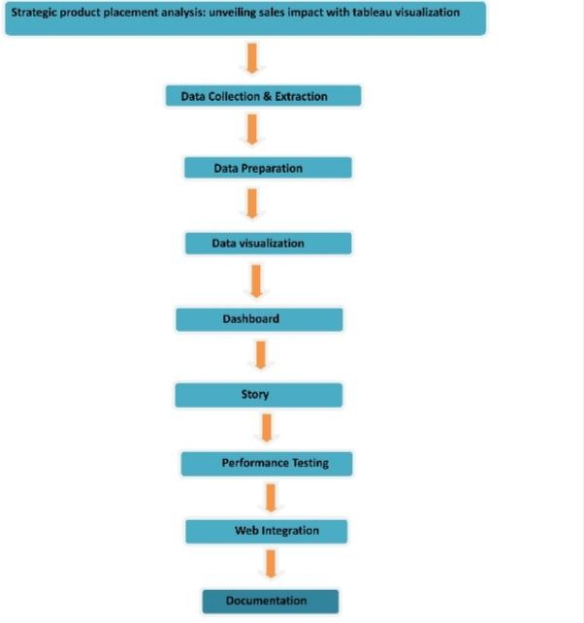

User Stories

User Type | Functional Requirement (Epic) | User Story Number | User Story / Task | Acceptanc e Criteria | Priority | Releas e
Retail Manager | Spatial Dashboard | USN-1 | As a manager, I want to see a Heat Map of the store floor. | I can  identify "Hot" and "Dead" zones | High | Sprint-1

 |  |  |  | visually.
Retail Manager | Profit Analysis | USN-2 | As a manager, I want to compare Eye-level vs. Bottom-shelf profit. | I can see a bar chart showing the margin difference. | High | Sprint-1
Category Analyst | Data Integration | USN-3 | As an analyst, I want to upload POS CSV files into the system. | Data is cleaned and mapped to store coordinates  . | High | Sprint-1
Category Analyst | Filtering | USN-4 | As an analyst, I want to filter sales by Product Category | I can see how "Snacks" perform vs "Dairy" in specific aisles. | Med | Sprint-2
Administra tor | Layout Config | USN-5 | As an admin, I want to update the store floor plan (X/Y map). | The Tableau map updates to reflect new aisle positions. | Med | Sprint-2
Executive | Reporting | USN-6 | As an executive, I want a Weekly Sales Lift report. | I receive an automated email with total revenue impact. | Low | Sprint-2

Project Design Phase-II

Technology Stack (Architecture & Stack)

Technical Architecture:

Data Sources:
Integrates unstructured planograms/calendars from Cloud Storage (Google Drive) with structured POS/inventory data from Database Servers.

Preparation:
Uses Tableau to clean SKU inconsistencies and join "Placement" metadata with actual "Sales" figures.

Analytics Engine:
A core modeling layer that calculates specific KPIs like Eye-Level Lift and End-Cap Conversion Rates.

Distribution:
Hosted on Tableau Server/Cloud for security and automated data refreshes.

Accessibility:
Features a Responsive Design optimized for mobile, tablet, and desktop viewing.

User Action:
Enables Category Managers to make rapid "Keep or Move" decisions based on real-time impact visualization.

Core Impact Metrics

To keep the analysis focused, the system prioritizes these three high-level views:

Placement ROI:
Sales growth vs. the cost of premium shelf space.

Heatmap Analysis:
Visualizing "Hot Zones" vs. "Dead Zones" within a store aisle.

A/B Testing:
Direct comparison of sales performance across two different placement strategies

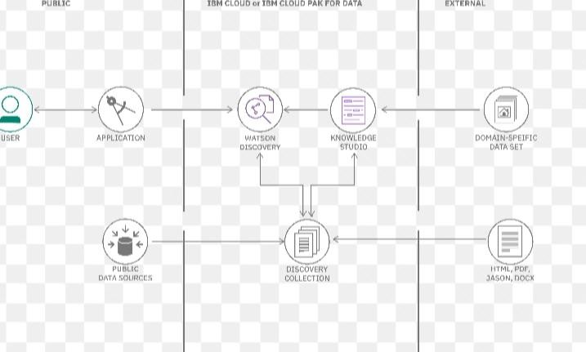

Table-1 : Components & Technologies:

S.No | Component | Description | Technology
1. | User Interface | Responsive Web and Mobile UI for interactive dashboard viewing. | Tableau Web / Mobile App
2. | Application Logic-1 | Data harmonization and ETL to merge planograms with sales data. | Tableau Prep / Python
3. | Application Logic-2 | Impact modeling to calculate Eye-level vs. | Bottom-shelf sales lift. Tableau Desktop / SQL
4. | Application Logic-3 | Automated refresh  scheduling for real-time sales trend monitoring. | Tableau Server Scheduler

5. | Database | Stores structured historical POS transactions and store metadata. | MySQL / PostgreSQL
6. | Cloud Database | High-speed warehouse for aggregating multi-store retail datasets. | Snowflake / Google BigQuery
7. | File Storage | Storage for flat-file planograms and manual store audit logs. | Google Drive / Local Filesystem
8. | External API-1 | Normalizes sales data based on local weather or seasonal trends. | IBM Weather API
9. | External API-2 | Automates user permission syncing and programmatic report delivery. | Tableau REST API
10. | Machine Learning | Forecasts potential  revenue lift for proposed shelf-space changes. | Python (Scikit-learn)
11. | Infrastructure | Secure cloud deployment for 24/7 multi-device accessibility. | Tableau Cloud / Kubernetes

Table-2: Application Characteristics:

S.No | Characteristics | Description | Technology
1. | Open-Source Frameworks | Utilizing open-source tools for data transformation and | Python (Pandas/NumPy), PostgreSQL,

 |  | visualization agility. | Open-source API connectors
2. | Security Implementations | Multi-layered security with Row-Level Security (RLS) and encrypted data transit. | SHA-256,  SAML/SSO, Tableau RLS, SSL/TLS  Encryption.
3. | Scalable Architecture | A 3-tier architecture (Data, Logic, Presentation) designed for multi-device growth. | Micro-services, Kubernetes, Tableau Cloud Clusters.
4. | Availability | High availability through distributed servers and automated health checks. | Load Balancers, AWS Multi-AZ, Tableau Server High Availability.
5 | Performance | Optimized query execution through data extracts and caching for fast load times. | Redis Caching, Tableau Data Hyper Extracts, CDN (CloudFront).

6 Project Design Phase
Problem – Solution Fit Template Problem – Solution Fit
Retail stores often struggle to understand how product placement (eye-level shelves, end caps,
checkout counters, aisle positioning) impacts sales performance. Decisions about placement
are frequently based on assumptions rather than data, leading to:

Purpose
- To analyze the impact of product placement on overall sales performance.
- To identify high-performing shelf positions such as eye-level, end caps, and checkout
areas.
- To use Tableau for creating interactive dashboards and visual reports.

- To compare sales performance before and after placement changes.
- To optimize store layout for better space utilization and higher revenue.
- To support data-driven decision-making in retail management.
- To improve visibility of high-margin and promotional products.
- To enhance overall profitability through strategic product positioning.
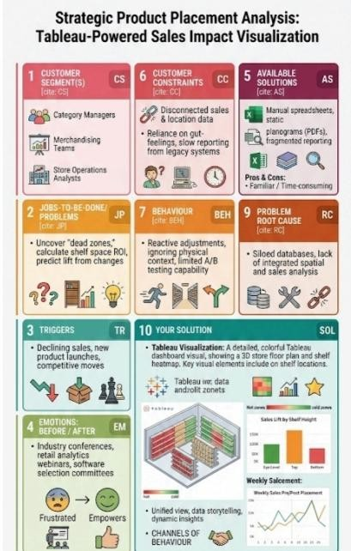

Project Design Phase Proposed Solution Template

Proposed Solution Template:

Project team shall fill the following information in the proposed solution template

S.No. | Parameter | Description
1 | Problem Statement (Problem to be solved) | Retail stores apply various product placement  strategies to boost sales but often lack clear insight into their effectiveness. This study analyzes the impact of strategic placement on  overall sales performance and uses Tableau to  visualize data and identify the most effective  strategies for increasing revenue and improving  business decisions.
2 | Idea / Solution description | This project, Strategic Product Placement Analysis: Unveiling Sales Impact with Tableau  Visualization, aims to examine how different  product placement strategies influence retail sales performance. By analyzing data such as  shelf position, promotional displays, product categories, and store locations, the project identifies patterns that affect customer purchasing behavior.  Using Tableau
3 | Novelty /  Uniqueness | This project uniquely combines retail merchandising strategies with advanced data visualization to analyze the impact of product

placement on sales. Using Tableau, it transforms
raw sales data into clear, interactive insights that
help retailers optimize store layouts, compare
4 | Social Impact / Customer Satisfaction | By analyzing sales patterns using Tableau, retailers can place products in more convenient  and visible locations, making shopping faster and  more comfortable. This leads to higher customer
5 | Business Model (Revenue Model) | By using insights generated from Tableau, businesses can identify high-performing shelf  positions and promotional areas to maximize
6 | Scalability of the Solution | The solution can be expanded to different retail  formats such as supermarkets, malls, and  e-commerce platforms. It can also incorporate  advanced analytics and predictive modeling in  the future, making it adaptable for both small  retailers and large retail chains.

Project Design Phase Solution Architecture

Solution Architecture: Data Sources Layer

  - Point of Sale (POS) Systems – Transaction-level sales data (product, quantity, revenue,
date, store).
  - Inventory Database – Stock levels, product categories, shelf allocation.
  - Store Layout Data – Product placement zones (entrance, aisle-end, eye-level shelves,
checkout counters).
  - Promotional Data – Discounts, campaigns, in-store offers. Data Integration & Preparation Layer
  - Data Extraction – Connect Tableau to SQL databases, Excel files, or cloud storage.
  - Data Cleaning – Remove duplicates, standardize product names, handle missing values.
  - Data Transformation –
  - Create calculated fields (Sales Growth %, Average Basket Size, Placement Impact
Score).
  - Merge sales data with placement zones.
  - Data Aggregation – Summarize by product, category, placement zone, and time period.

Data Storage Layer

  - Centralized Data Warehouse / Data Mart
  - Structured tables for:
  - Sales Facts
  - Product Dimensions
  - Store Dimensions
  - Placement Dimensions

Analytics & Business Logic Layer

  - KPI Calculations:
  - Total Sales
  - Sales by Placement Zone
  - Conversion Rate
  - Revenue per Square Foot
  - Before vs After Placement Comparison
  - Trend Analysis (Weekly / Monthly / Seasonal)

  - Correlation analysis between placement position and sales performance

Visualization Layer (Using Tableau) Interactive dashboards built in Tableau:

  - Sales by Placement Heatmap
  - Trend Analysis Line Charts
  - Product Category Performance Dashboard
  - Store-wise Placement Impact Comparison
  - Shelf Position vs Revenue Bar Charts

User Layer
  - Retail Managers
  - Category Managers
  - Marketing Team
  - Store Operations Team
  - Business Analysts

Deployment & Maintenance

  - Publish dashboards to Tableau Server / Tableau Cloud
  - Schedule automatic data refresh
  - Role-based access control
  - Performance monitoring and periodic optimization

Project Planning Phase
Project Planning Template (Product Backlog, Sprint Planning, Stories, Story points)

Product Backlog, Sprint Schedule, and Estimation (4 Marks)
Use the below template to create product backlog and sprint schedule

Sprint | Functional  Requirement (Epic) | User Story  Number | User Story / Task | Story Points | Priority | Team Members
Sprint-1 | Data Collection and Extraction of Data | USN-1 | - Collect the dataset  - Understanding the Data  - Connecting the | 3 | High | Labala Deekshitha

 |  |  | dataset with Tableau
Sprint-1 | Data Preparation | USN-2 | Prepare the Data for Visualization | 5 | High | Maddila Parvathi
Sprint-2 | Data Visualization | USN-3 | No of Unique Visualizations | 4 | Low | Labala Deekshitha
Sprint-1 | Dashboard | USN-4 | Responsive and Design of Dashboard | 3 | Medium | Komati Krishnaveni
Sprint-1 | Story | USN-5 | No of Scenes of Story | 5 | High | Koppala Sailaja
Sprint-2 | Performance Testing | USN-6 | - Utilization of Filters  - No of Calculation Fields  - No of Visualizations/ Graphs | 8 | High | Komati Krishnaveni
Sprint-3 | Web integration | USN-7 | Dashboard and Story embed with UI With Flask | 5 | High | Koppala Sailaja
Sprint-4 | Project Demonstration & Documentation | USN-8 | - Record an explanation Video for the project end to end solution  2 Project  Documentation-S tep by step project development | 4 | High | Labala Deekshitha

procedure

Project Tracker, Velocity & Burndown Chart: (4 Marks)

Sprint | Total Story Points | Duration | Sprint start date | Sprint end Date (planned) | Story points completed( as on  planned end Date) | Sprint release date (actual)
Sprint-1 | Data Collection and Extraction of Data | 6 days | 4/2/2026 | 10 | 20 | 4/2/2026
Sprint-2 | Data Preparation | 3 days | 10/2/2026 | 13 | 20 | 10/2/2026
Sprint-3 | Data Visualizatio n | 3days | 13/2/2026 | 16 | 20 | 13/2/2026
Sprint-4 | Dashboard | 2 days | 16/2/2026 | 18 | 20 | 16/2/2026
Sprint-5 | Story | 2 days | 19/2/2026 | 21 | 20 | 19/2/2026
Sprint-6 | Performanc e Testing | 2days | 21/2/2026 | 22 | 20 | 21/2/2026
Sprint-7 | Web integration | 2days | 22/2/2026 | 23 | 20 | 22/2/2026
Sprint-8 | Project Demonstrat ion &  Documenta tion | 4 days | 23/2/2026 | 27 | 20 | 23/2/2026

Velocity:
Imagine we have a 10-day sprint duration, and the velocity of the team is 20 (points per sprint). Let’s calculate the team’s average velocity (AV) per iteration unit (story points per day)
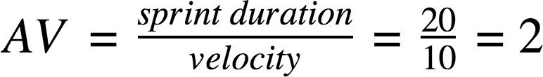

- Project Development Phase Model Performance Test Model Performance Testing:

Project team shall fill the following information in model performance testing template

S.No | Parameter | Screen shot / values
1 | Data Rendered | Displayed sales performance data across store zones, product categories, and promotion periods. Shows rendered Heat Map (Store Hot Zones), Scatter Plot (Correlation between shelf height and sales),  Side-by-Side Bar Chart (Placement A vs. Placement B), and KPI Cards (Total Revenue, Conversion Rate, Placement Lift %).
2 | Data Preprocessing | Cleaned transactional records, handled missing store IDs, standardized currency formats, and converted inventory units. Created a Product Hierarchy (Department > Category > SKU) and Location Hierarchy (Region > Store > Aisle >

 |  | Shelf).
3 | Utilization of Filter | Filters applied: Store Location, Product Category, Time Frame (Seasonal/Holiday), Placement Type (End-cap, Eye-level, Floor stack), and Customer Loyalty Tier. Enables users to isolate the impact of specific display changes on sales volume.
4 | Calculation Fields Used | Sales Lift (%) = \frac{\text{Sales (Strategic)} - \text{Sales (Standard)}}{\text{Sales (Standard)}} Conversion Rate =  \frac{\text{Transactions}}{\text{Footfa ll Count}}  Revenue Velocity = \frac{\text{Total Revenue}}{\text{Days on Display}}
5 | Dashboard Design | No. of Visualizations:  (Heat Map – Foot traffic vs. Sales; Scatter Plot – Shelf position impact; Bar Chart – Category comparison; Highlight Table – Weekday performance; KPI Cards – Revenue & Lift metrics).
6 | Story Design | Executive Summary, Aisle Performance Breakdown, Product Visibility Impact, Promotional Lift Analysis, and Space Optimization Recommendations.

Data Visualization

Activity 1.1: Avg Sales Volume vs Product Category

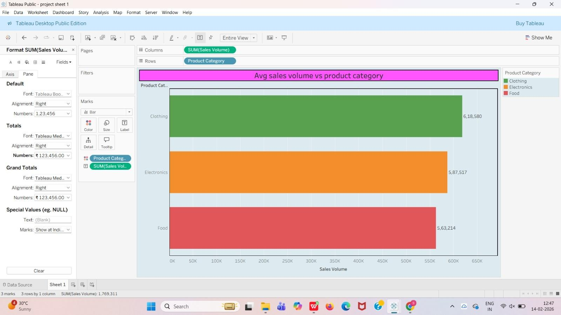

Activity 1.2: Competitor Price Vs Price

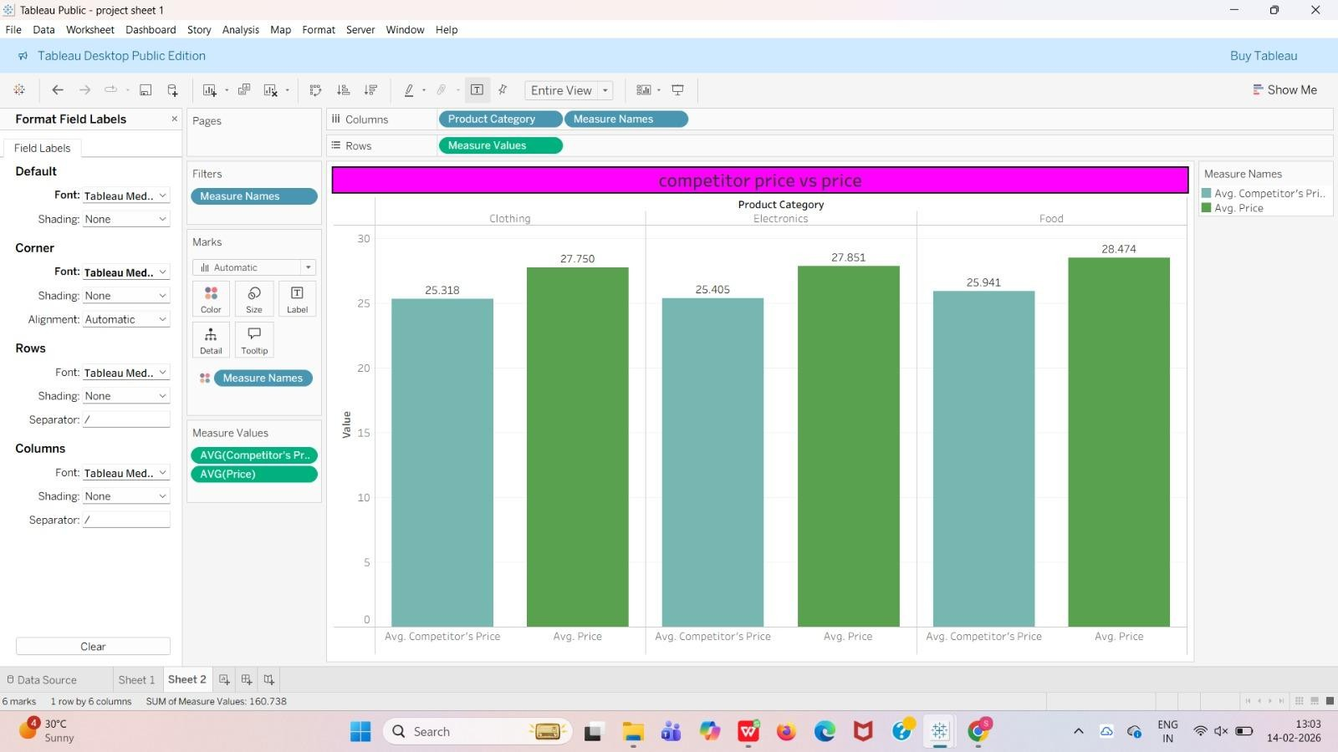

Activity 1.3: Avg Sales Volume by Product Category by Product Position

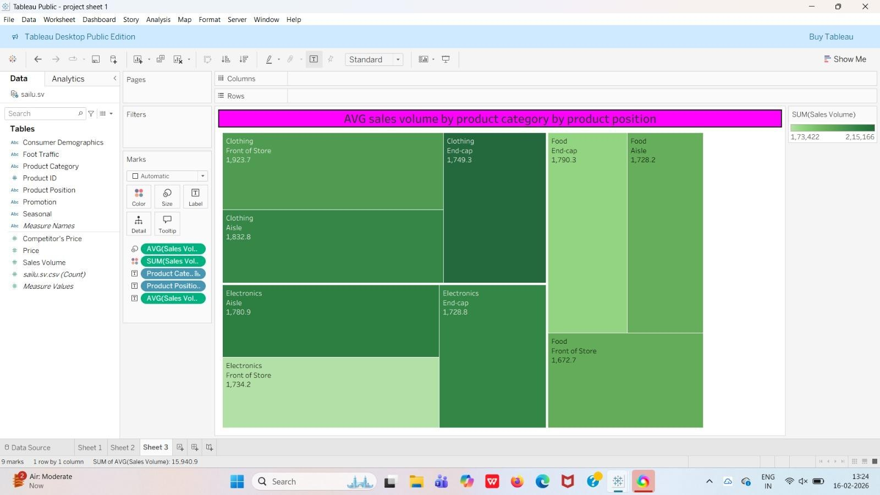

Activity 1.4: Consumer Demographics vs Sales Volume
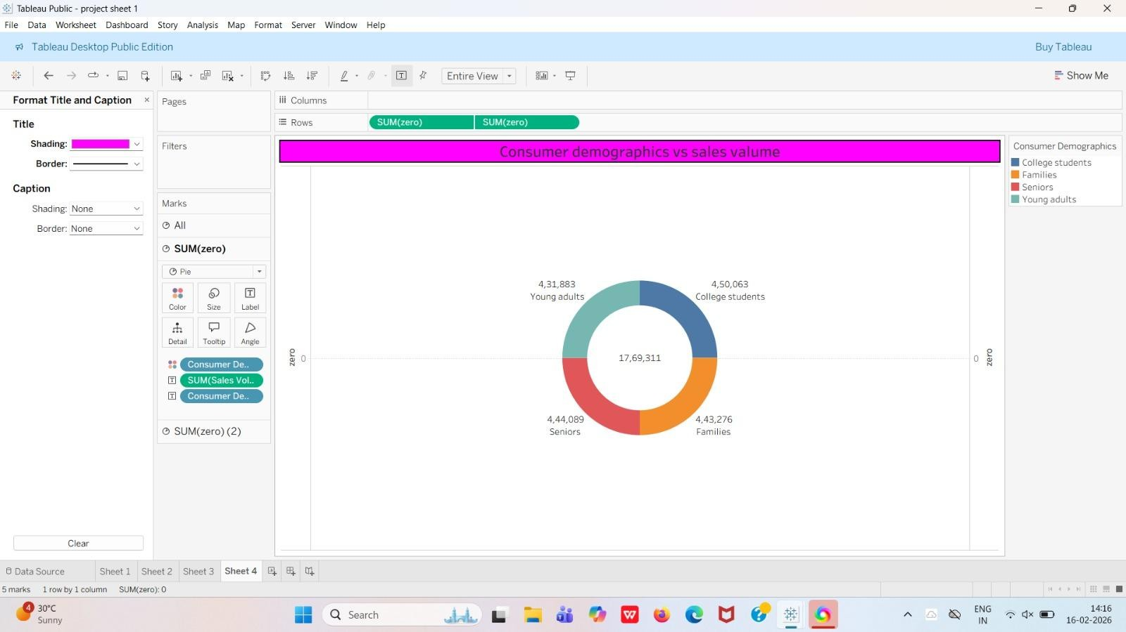

Activity 1.5: Product Category vs Price

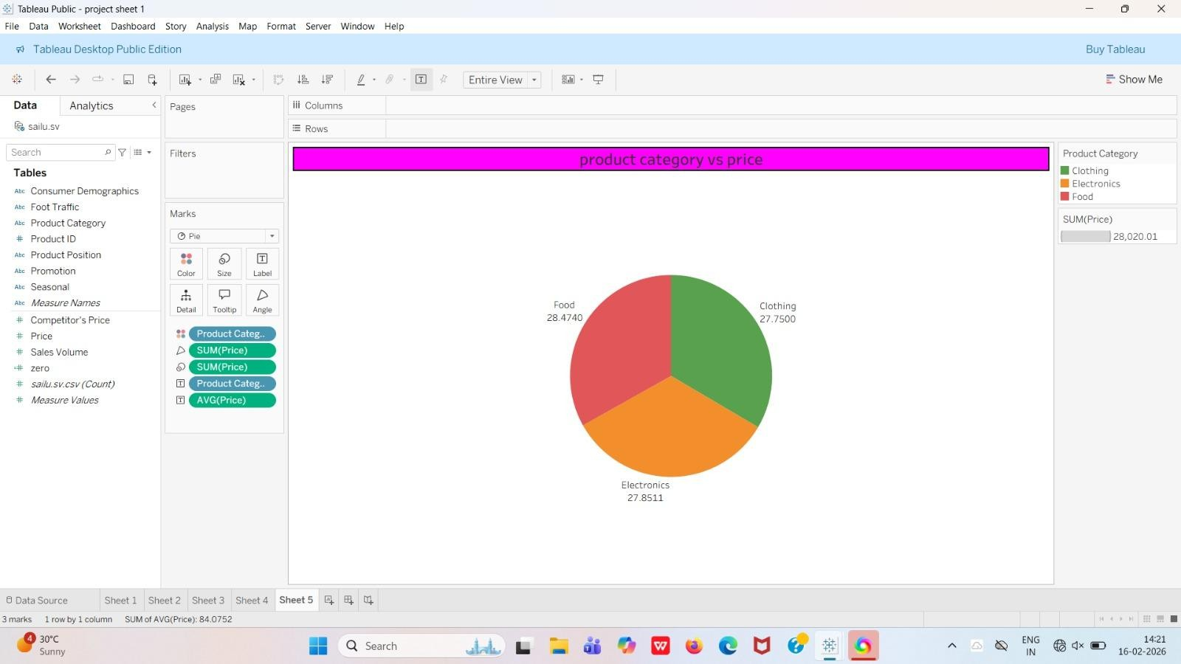

Activity 1.6: Avg Sales Volume by Product Category by Season
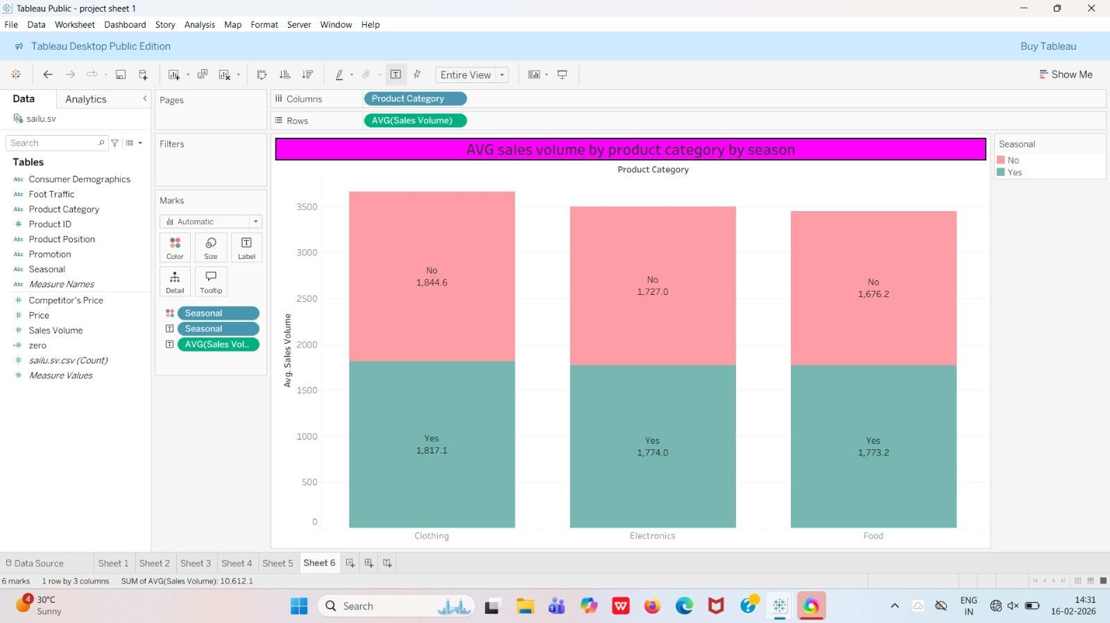

Activity 1.7: Foot Traffic by Avg Sales Volume

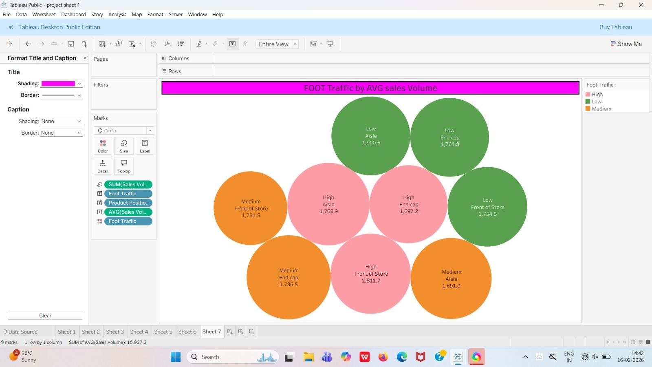

Activity 1.8: Promotion of Product Category on Price and Sales Volume
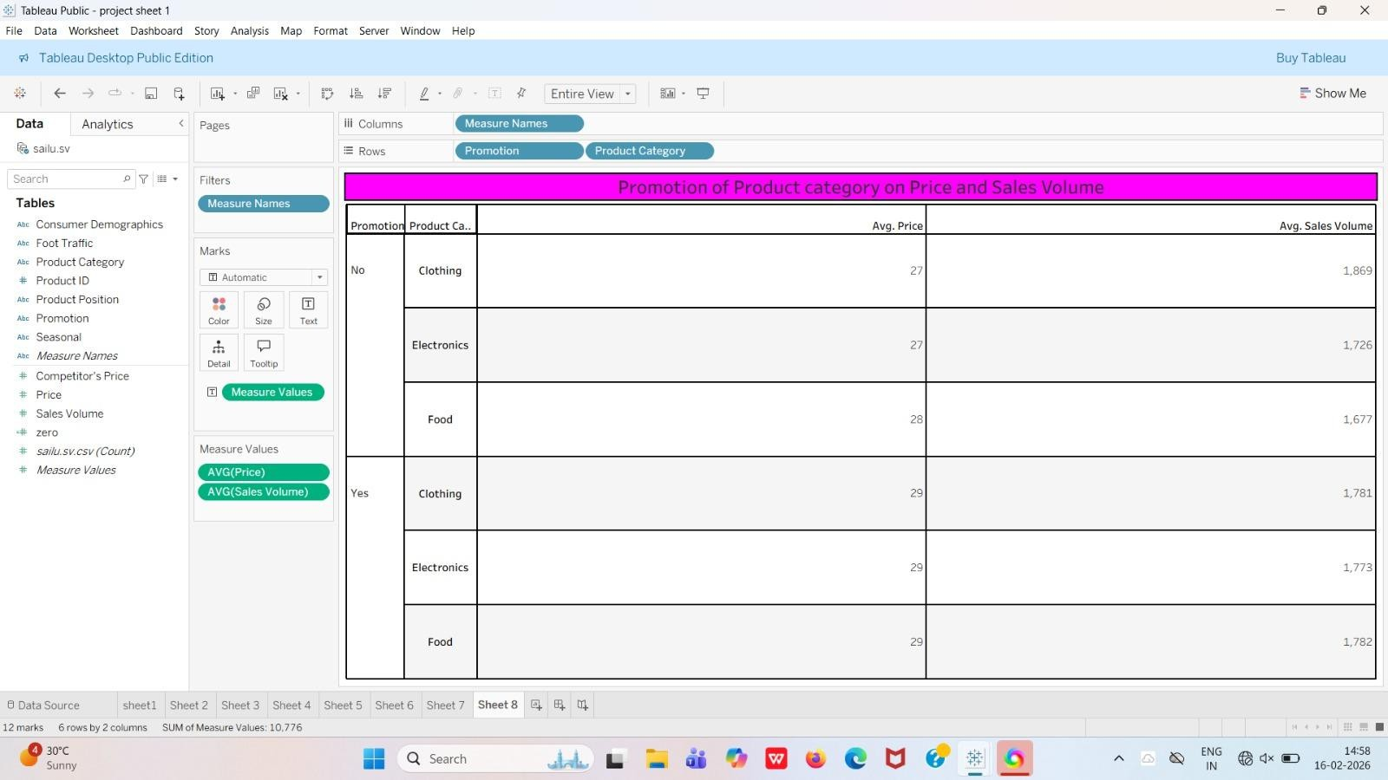

Dashboard:

Dashboard: Product Placement Analysis – Dashboard

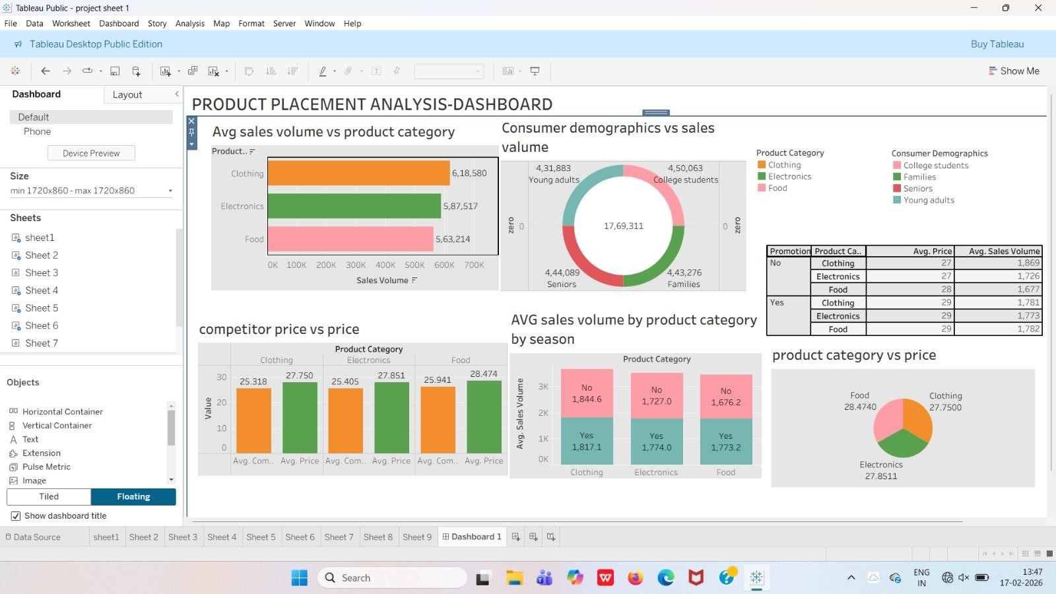

5) Story

Product Placement Analysis – Story
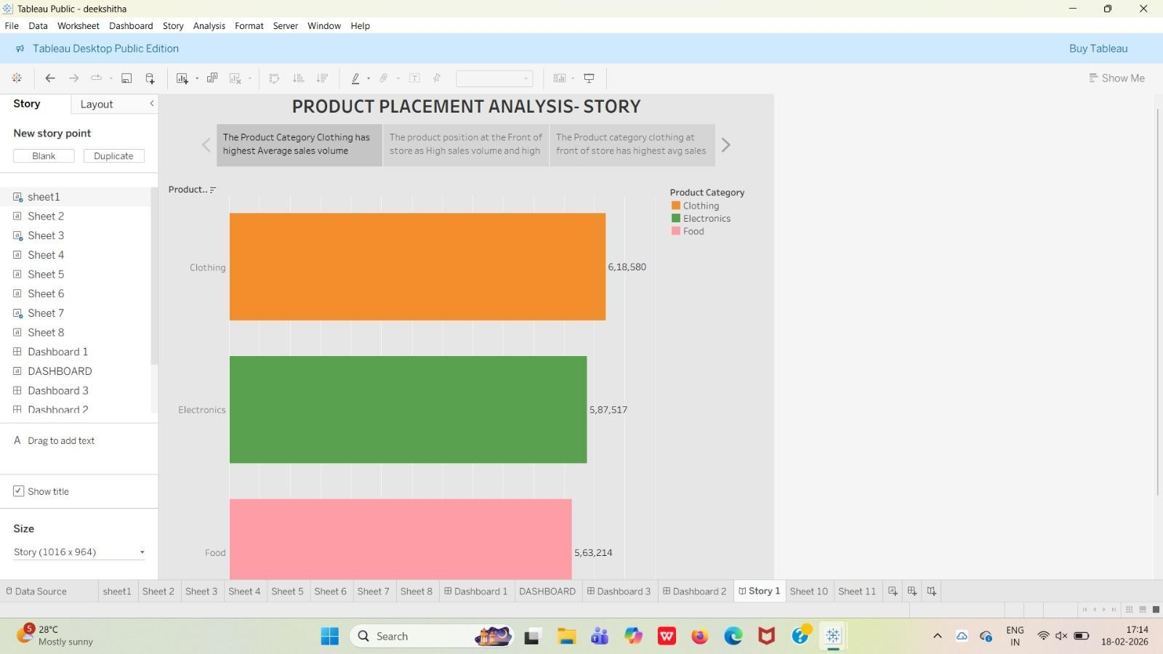

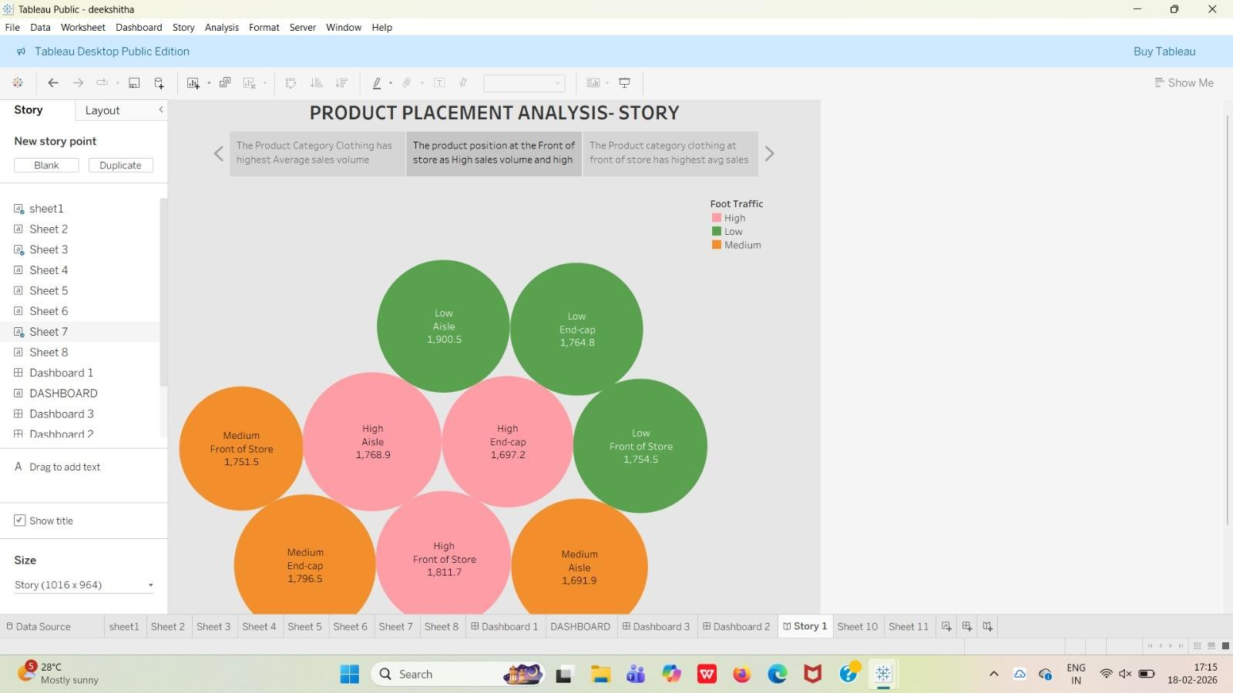

Web integration
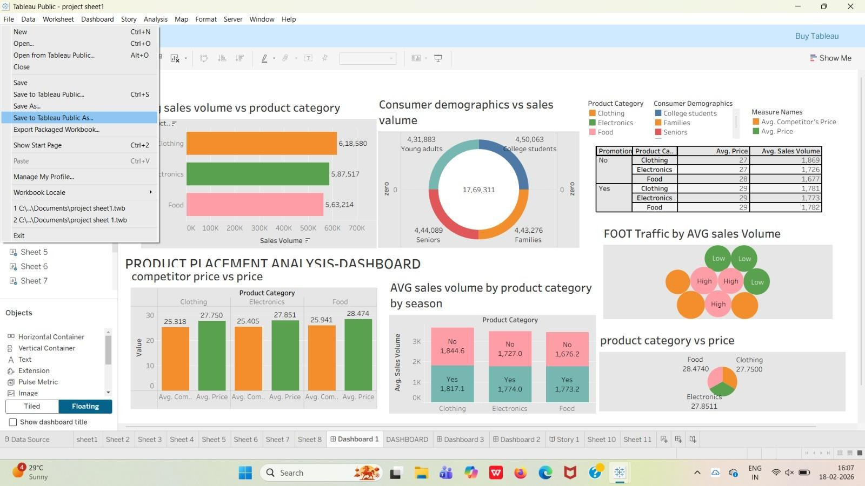

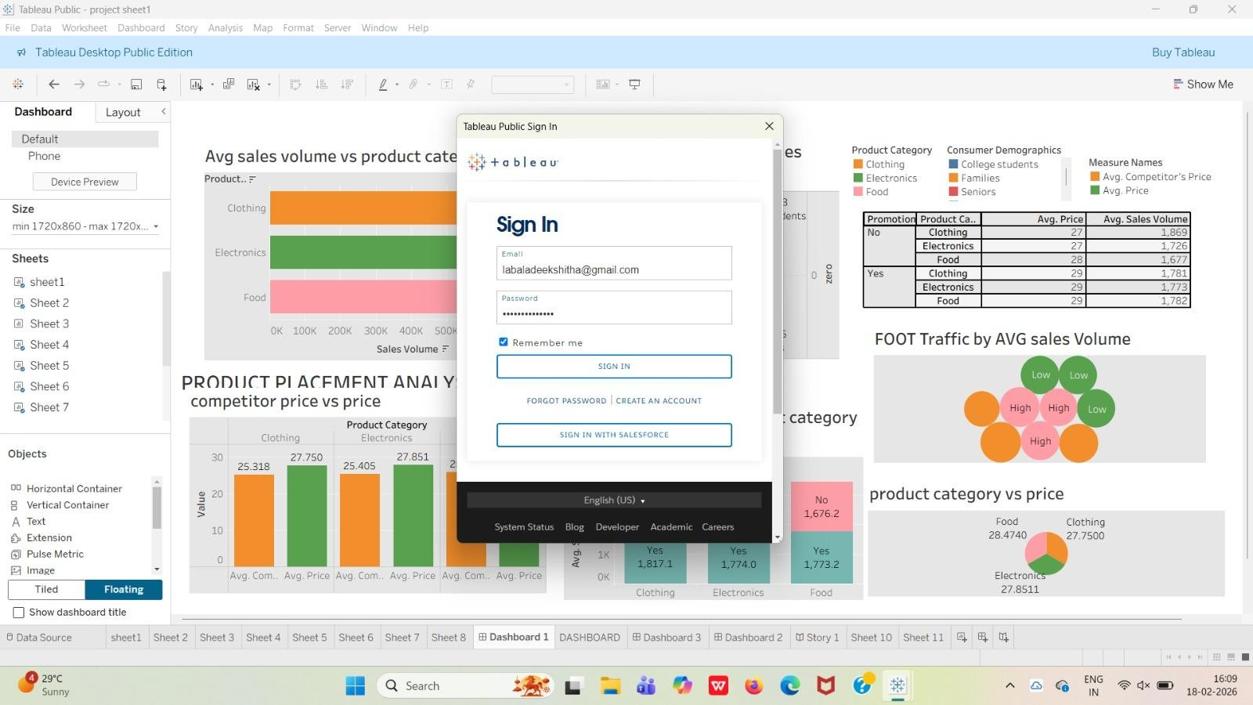
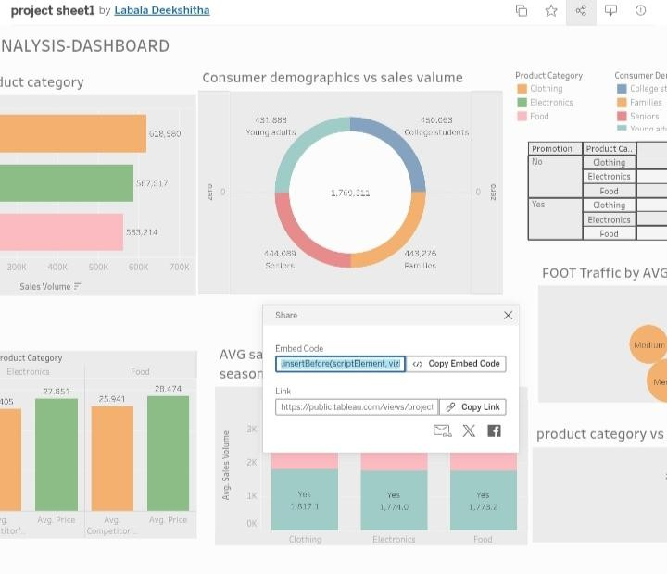

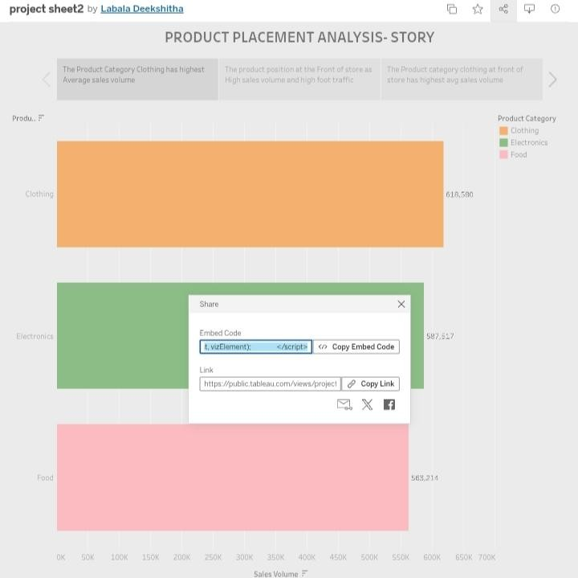

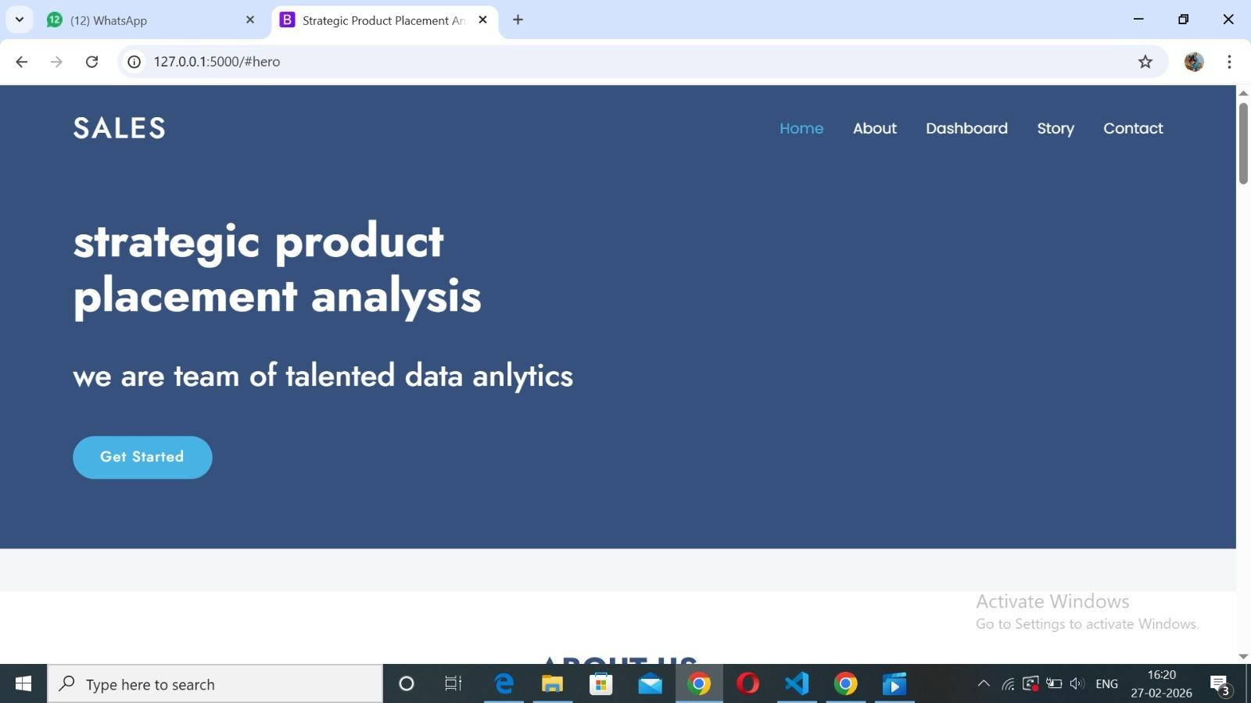

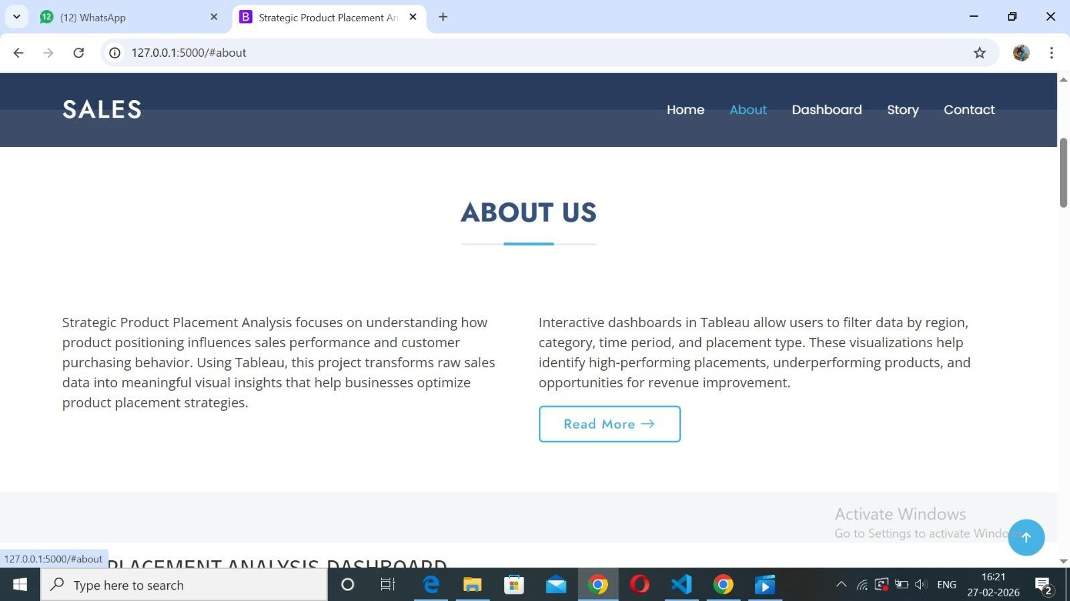

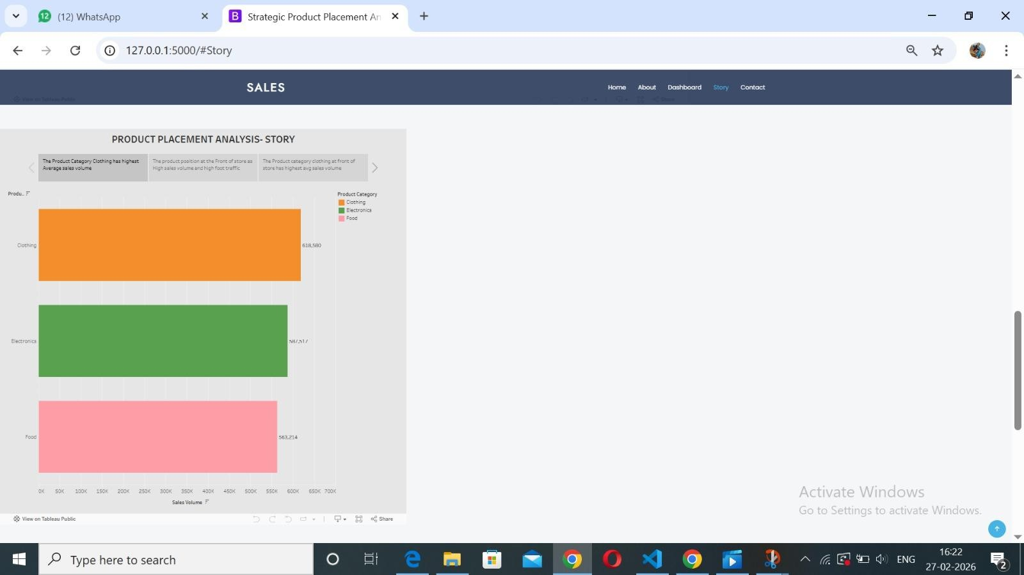

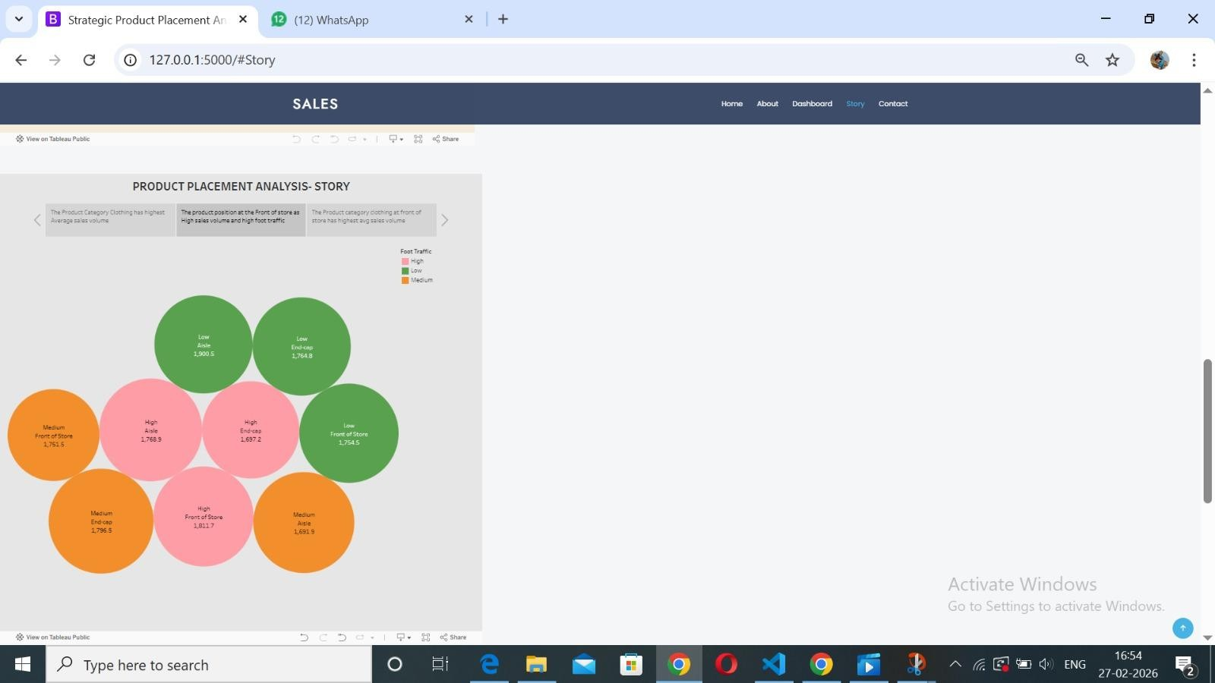

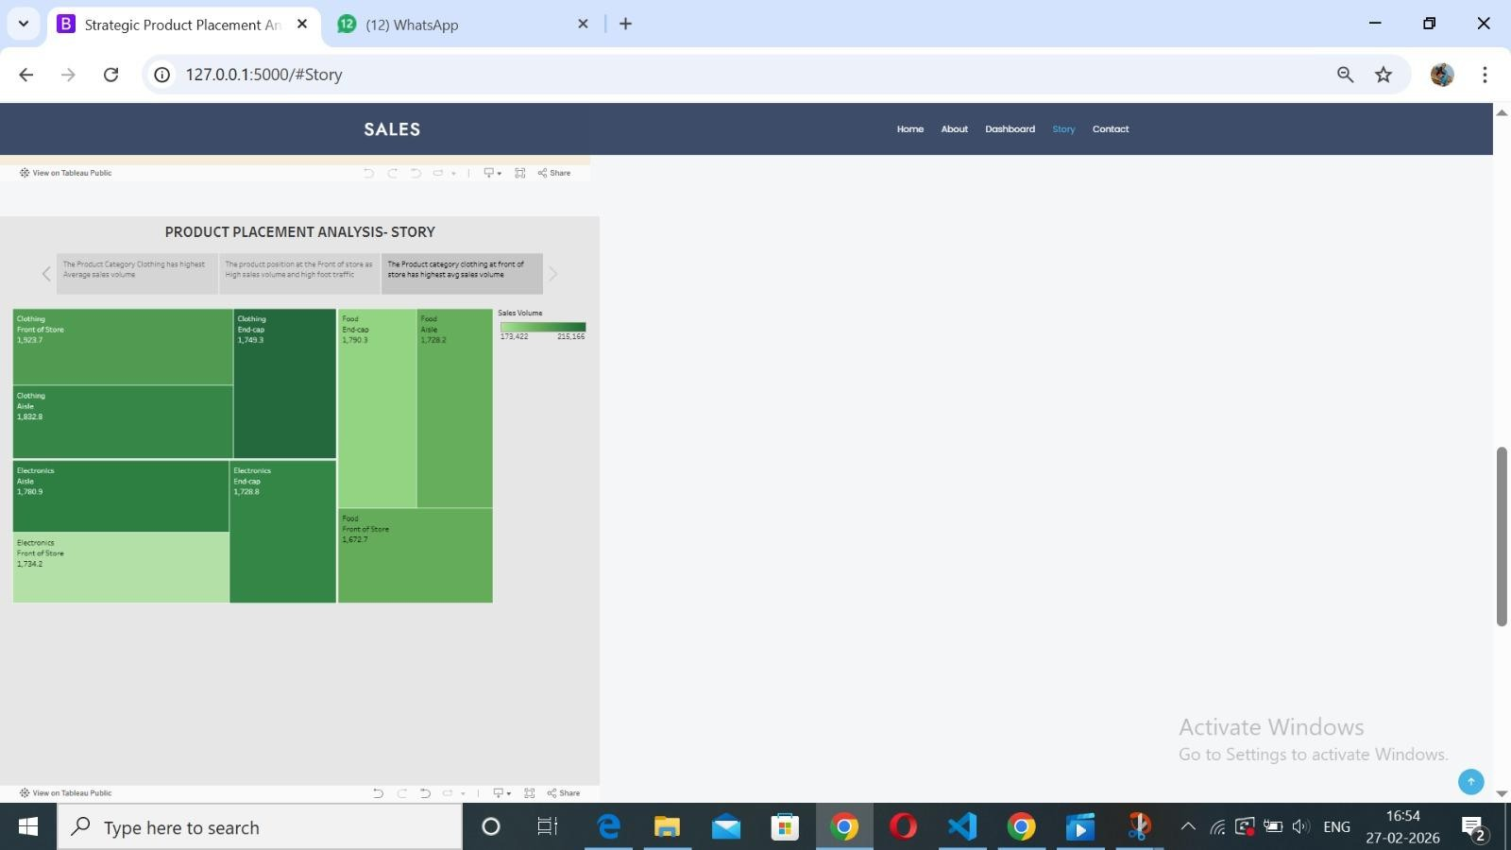

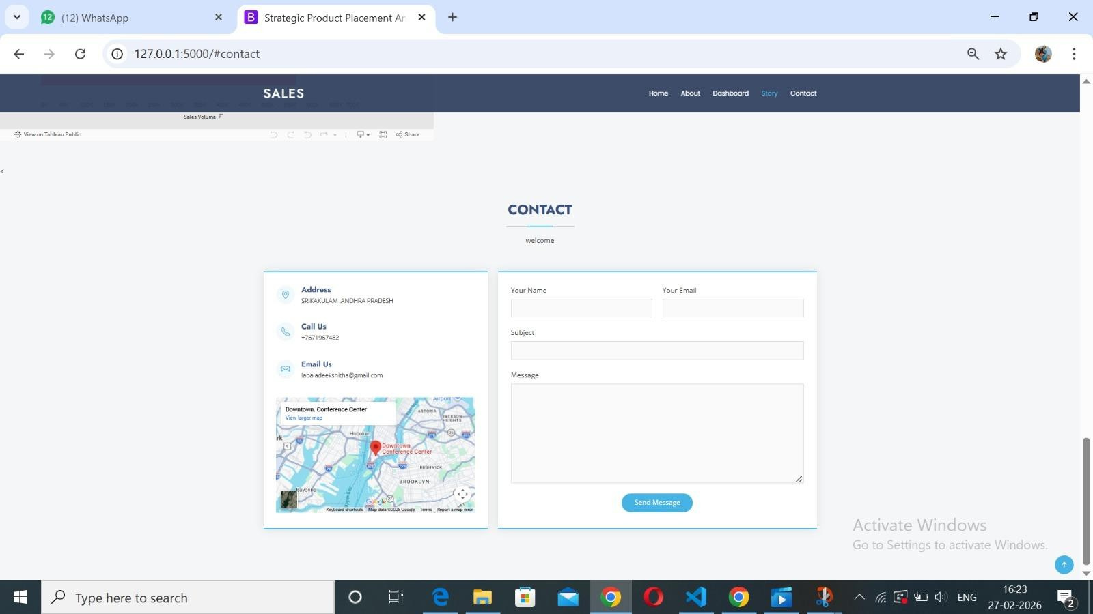

ADVANTAGES AND DISADVANTAGES

Advantages

Data-Driven ROI: Replaces guesswork with exact "Sales Lift" metrics for every shelf position. Visual Clarity: Uses Tableau heatmaps to instantly identify high-traffic "Hot Zones" and underperforming "Cold Zones".

Unified Insights: Merges siloed data from SQL databases and Google Drive into one accessible dashboard.
Real-Time Agility: Enables store managers to make immediate layout adjustments based on live performance data.
Consumer Understanding: Links demographics (Families, Seniors) to specific placement success for targeted marketing.

Disadvantages

Data Complexity: Requires significant effort in the "Data Preparation" phase to clean and transform raw POS records.
Integration Hurdles: Initial setup to connect Google Drive planograms with SQL databases can be technically challenging.
Maintenance Needs: Dashboards require regular updates to account for seasonal product changes and new SKUs.
High Initial Effort: Sprint-1 and Sprint-2 require heavy lifting from team members before any visual insights are produced.
Human Bias: Even with data, physical store constraints (e.g., fixed heavy shelving) may limit the ability to move products to "ideal" spots.

Conclusion

The Strategic Product Placement Analysis project successfully demonstrates how data-driven visualization can transform traditional retail management into a high-precision science. By bridging the gap between raw sales figures and physical store geography, the project provides a comprehensive solution for "unveiling" the hidden drivers of consumer behavior.

FUTURE SCOPE
Predictive AI Integration: Incorporating Machine Learning models to predict "Sales Lift" before a physical layout change is even made.

Real-Time IoT Sensors: Using in-store shelf sensors to update Tableau heatmaps instantly as products are picked up, rather than waiting for POS sync.
AR Visualization: Developing Augmented Reality (AR) tools for store managers to overlay Tableau performance metrics directly onto physical shelves using mobile devices.
Advanced Demographic Filtering: Integrating loyalty card data to track individual "Shopper Journeys" beyond broad categories like "Families" or "Seniors".
Automated Reordering: Linking shelf-level performance data to supply chain systems to automatically trigger restocks for high-velocity "Hot Zones".
Global Store Benchmarking: Expanding the Flask UI to compare placement effectiveness across multiple geographic locations or store formats.

APPENDIX
Source Code(if any) Flask Folder link:

https://drive.google.com/drive/folders/15abhxtDxY48c_5iDZz62ENd9pR4aT33l?usp=sharin g
Dataset link
https://www.kaggle.com/datasets/amitvkulkarni/impact-of-product-positioning-on-sales Dashboard Public Link: https://public.tableau.com/views/projectsheet1_17714887574540/Dashboard1?:language=en-US&publish=yes&:sid=&:redirect=auth&:display_count=n&:origin=viz_share_link
Story Public Link: https://public.tableau.com/views/projectsheet2_17714891134110/Story1?:language=en-US& publish=yes&:sid=&:redirect=auth&:display_count=n&:origin=viz_share_link

